**Foothills Lions Club (FLC)**  **DATE: .**

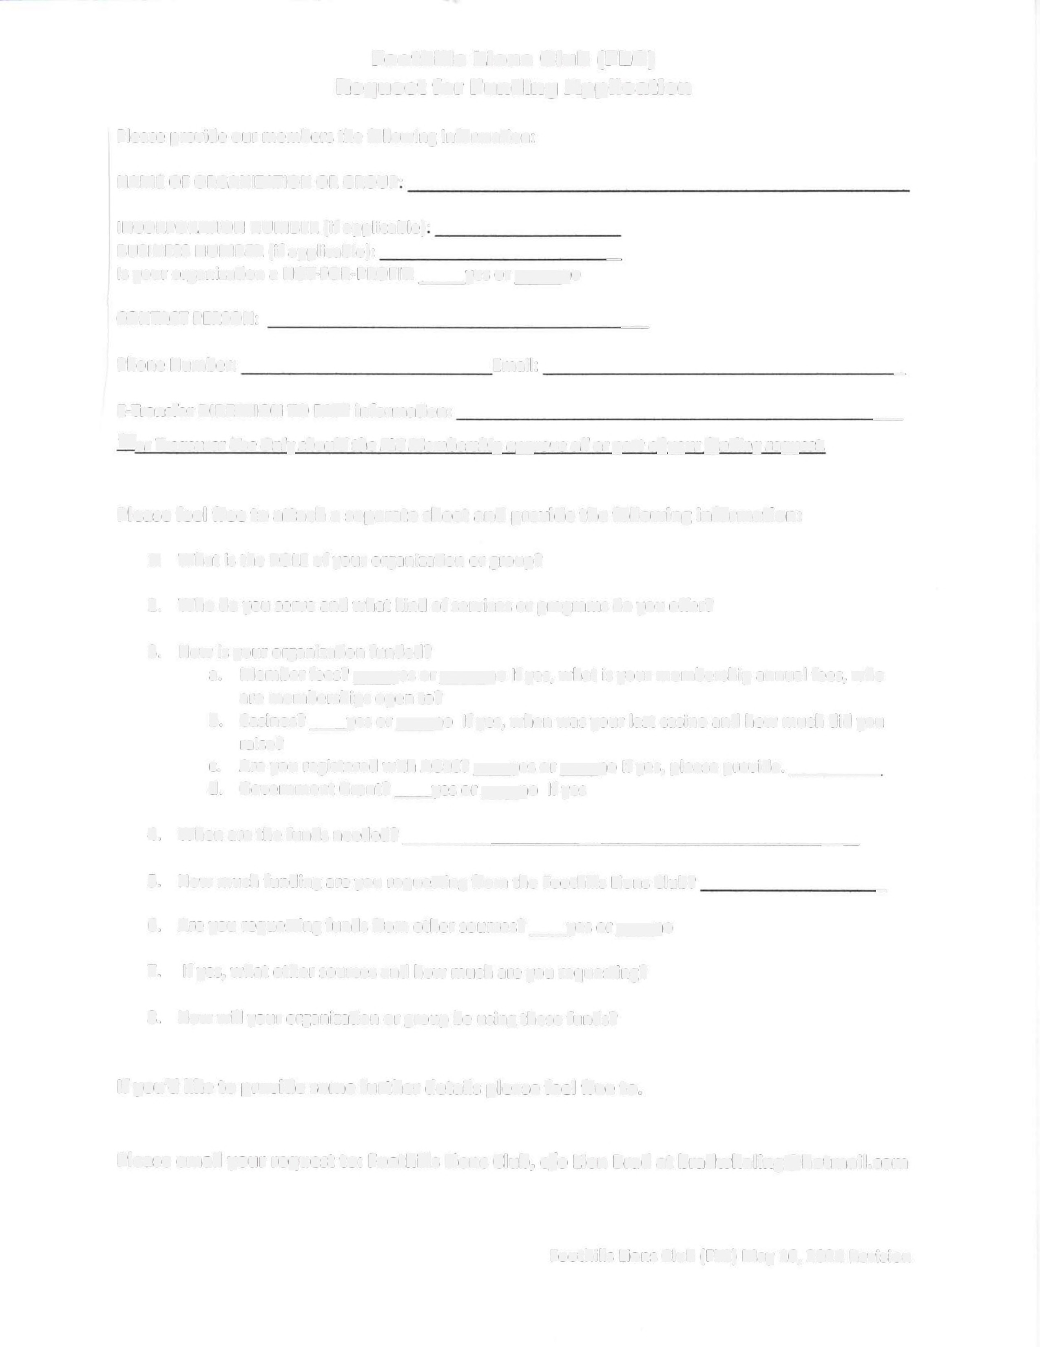

**Request for Funding Application**

|  |  |  |
| --- | --- | --- |
| Please provide our members the following information: NAME OF ORGAN[ZATION OR GROUP.  INCORPORATION NUMBER (if applicable). |  |  |
| BUSINESS NUMBER (if applicable): | _ |
| Is your organization a NOT-FOR-PROFIT: _Yes or No |  |
| CONTACT PERSON: | _ |
| Phone Number: Email: |  | _ |
| **E-Transfer DIRECTION TO PAY information:** |  | **_** |

***For Treasurer Use Only should the FLC Membership approve all or part of your funding request,***

**Please feel free to attach a separate sheet and provide the following information:**

1. What is the ROLE of your organization or group?

2. Who do you serve and what kind of services or programs do you offer?

3. How is your organization funded?

a. Member fees? Yes or No If yes, what is your membership annual fees, who are memberships open to?

b. Casinos? Yes or No If yes, when was your last casino and how much did you raise?

c. Are you registered with AGLC? Yes or No If yes, please provide #: _

d. Government Grant? Yes or No If yes, please provide value: _

|  |  |  |
| --- | --- | --- |
| 4. | When are the funds needed? . |  |
| 5. | How much funding are you requesting from the Foothills Lions Club? | _ |
| 6. | Are you requesting funds from other sources? Yes or No. |  |
| 7. | If yes, what other sources and how much are you requesting? |  |
| 8. | How will your organization or group be using these funds? |  |

If you'd like to provide some further details, please feel free to.

Please email your request to: Foothills Lions Club, Brad Whaling [bradwhaling@hotmail.com](mailto:bradwhaling@hotmail.com) c/o [Info@foothillslionsclub.ca](mailto:Info@foothillslionsclub.ca)

Foothills Lions Club (FLC) May 16, 2024 Revision